- Key Features of Angular:
- Component-based architecture:
  - Everything in Angular is a component. Components are the building blocks of an Angular application, each representing a part of the UI. Components consist of an HTML template, CSS styles, and a TypeScript class.
- Two-way data binding:
  - This allows changes in the UI to automatically update the model (data) and vice versa. This reduces the need for manual DOM manipulation.
- Dependency Injection (DI):
  - Angular provides a powerful dependency injection system that makes it easier to manage service instances and their dependencies.
- Routing:
  - Angular’s built-in routing module helps developers create a single-page application (SPA) by enabling navigation between different views or pages without refreshing the entire page.
- RxJS for reactive programming:
  - Angular uses RxJS, a reactive programming library, to handle asynchronous events, such as HTTP requests or user inputs, more efficiently.
- CLI (Command Line Interface):
  - The Angular CLI provides tools to automate common development tasks like creating components, services, and modules, running tests, and building the application.
- Ahead-of-Time (AOT) Compilation:
  - Angular compiles the code before the browser downloads and renders it. This improves performance as the code is already compiled and optimized.
- Modular structure:
  - Angular applications are built using modules that organize related components, services, and other functionalities into cohesive units. Modules make the application more maintainable and scalable.

How to Set Up a Basic Angular App:
- Install Node.js if it's not already installed: https://nodejs.org
- Install Angular CLI globally via npm:
npm install -g @angular/cli
- Create a new Angular project:
ng new my-angular-app
cd my-angular-app
- Serve the application:
ng serve
The app will run at http://localhost:4200.

REPORT on the "Contact Us" Form

1. Objectives
The purpose of this report is to evaluate the "Contact Us" Form created using HTML and Bootstrap 5. The goals of this project are:
- To design a responsive, user-friendly contact form for capturing essential user information (name, email, and message).
- To implement Bootstrap 5 for modern styling and responsiveness.
- To understand basic form validation and structure using HTML.
- To explore the potential for form enhancement with backend integration and advanced validation techniques.

2. Observations
a) Observations:

- Input & Output :

i)input(source code):
<!DOCTYPE html>
<html lang="en">
<head>
<meta charset="UTF-8">
<meta name="viewport" content="width=device-width, initial-scale=1.0">
<title>Contact Us Form</title>
<!-- Link to Bootstrap CSS (Make sure to use the version you need) -->
<link href="https://cdn.jsdelivr.net/npm/bootstrap@5.3.0-alpha1/dist/css/bootstrap.min.css" rel="stylesheet">
</head>
<body>
<div class="container my-5">
<h2 class="text-center mb-4">Contact Us</h2>
<form>
<div class="mb-3">
<div class="form-floating">
<input type="text" class="form-control" id="name" placeholder="Enter your name" required>
<label for="name">Full Name</label>
</div>
</div>
<div class="mb-3">
<div class="form-floating">
<input type="email" class="form-control" id="email" placeholder="Enter your email" required>
<label for="email">Email Address</label>
</div>
</div>
<div class="mb-3">
<div class="form-floating">
<textarea class="form-control" id="message" placeholder="Enter your message" rows="4" required></textarea>
<label for="message">Your Message</label>
</div>
<div class="alert alert-success d-none" id="success-message">Message sent successfully!</div>

</div>
<button type="submit" class="btn btn-primary w-100">Send Message</button>
</form>
</div>

<!-- Link to Bootstrap JS (for proper form behavior) -->
<script src="https://cdn.jsdelivr.net/npm/bootstrap@5.3.0-alpha1/dist/js/bootstrap.bundle.min.js">document.querySelector('form').addEventListener('submit', function(event) {
const email = document.getElementById('email');
if (!email.value.includes('@')) {
event.preventDefault();
email.classList.add('is-invalid');
}
});
</script>
</body></html>

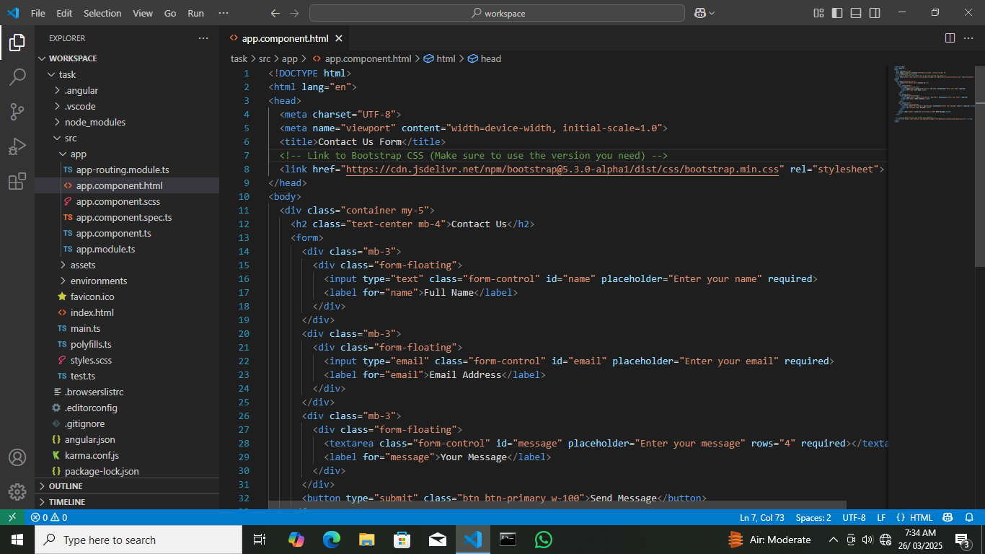
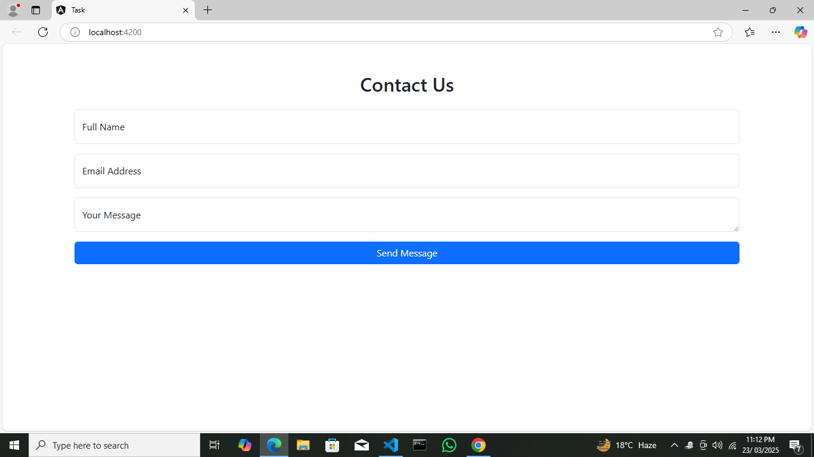
ii. Output:

a)Summary:
- The form is structured with Bootstrap 5 classes, ensuring a clean, responsive layout across devices.
- It includes floating labels for better user experience and minimalistic design.
- The form contains three key input fields:
  - Full Name (text input)
  - Email Address (email input)
  - Your Message (textarea)
- The "Send Message" button is prominently displayed, encouraging user interaction.
- The form currently lacks name attributes for the input fields, which are necessary for data submission to the server.

b) Insights Gained:
- Bootstrap's utility classes significantly simplify the process of building responsive forms.
- Understanding the importance of name attributes and form submission mechanics for backend integration.
- The floating label design improves clarity, especially on mobile devices.
- Realizing that a functional contact form requires not just frontend design but also backend processing for data handling.
C) SYSTEM REQUIREMENTS
- This phase involves identifying both hardware and software requirements needed to develop and run the responsive grid layout project smoothly. It ensures that the system environment supports proper implementation and testing of the design.
- Hardware Requirements:
- A computer/laptop with at least 4GB RAM
- Minimum 2 GHz processor
- 500 MB free disk space
- Internet connectivity for accessing online resources.

- Software Requirements:
- Code editor (Visual Studio Code or any IDE) Modern web browser (Chrome, Firefox, etc.)
- Operating System: Windows, macOS, or Linux
- Optional: Git for version control.

3. Conclusion
a) Summary of Outcomes:
- Successfully designed a responsive, user-friendly contact form using Bootstrap 5.
- Applied basic HTML form elements and learned how to structure forms effectively.
b) Learning Points:
- Responsive Web Design: Using Bootstrap to ensure the form adapts well to various screen sizes.
- Form Validation: Introduction to the required attribute for basic client-side validation.
- User Interface Design: Importance of floating labels and clear call-to-action buttons.
c) Challenges Faced:
- Missing name Attributes: Identifying that without name attributes, form data can't be submitted to a server.
- No Backend Integration: Understanding that the form is purely frontend without data processing capabilities.
- Lack of Validation Feedback: Realizing the need for enhanced user feedback (error messages, success notifications).
d) Relevance to Academic/Professional Goals:
- Academic Relevance: Enhances understanding of web development fundamentals, particularly in form design and Bootstrap usage.
- Professional Relevance: Builds foundational skills for creating forms in real-world applications, such as contact forms, surveys, and user registrations.
a) References
• Angular Docs: https://angular.dev/
• Bootstrap Docs: https://getbootstrap.com/
• Stack Overflow Discussions

